OVERVIEW

This document provides instructions for managing fund transfers in Sinai Cloud. The purpose of this procedure is to process funds transfers between two projects (funds) when required. This process can also be used to split a single cost from one project to multiple projects as needed.

AUDIENCE

- Department Users

Managing Fund Transfers

- In the Menu Ribbon, select the Projects tab.
- Select the Costs tile.

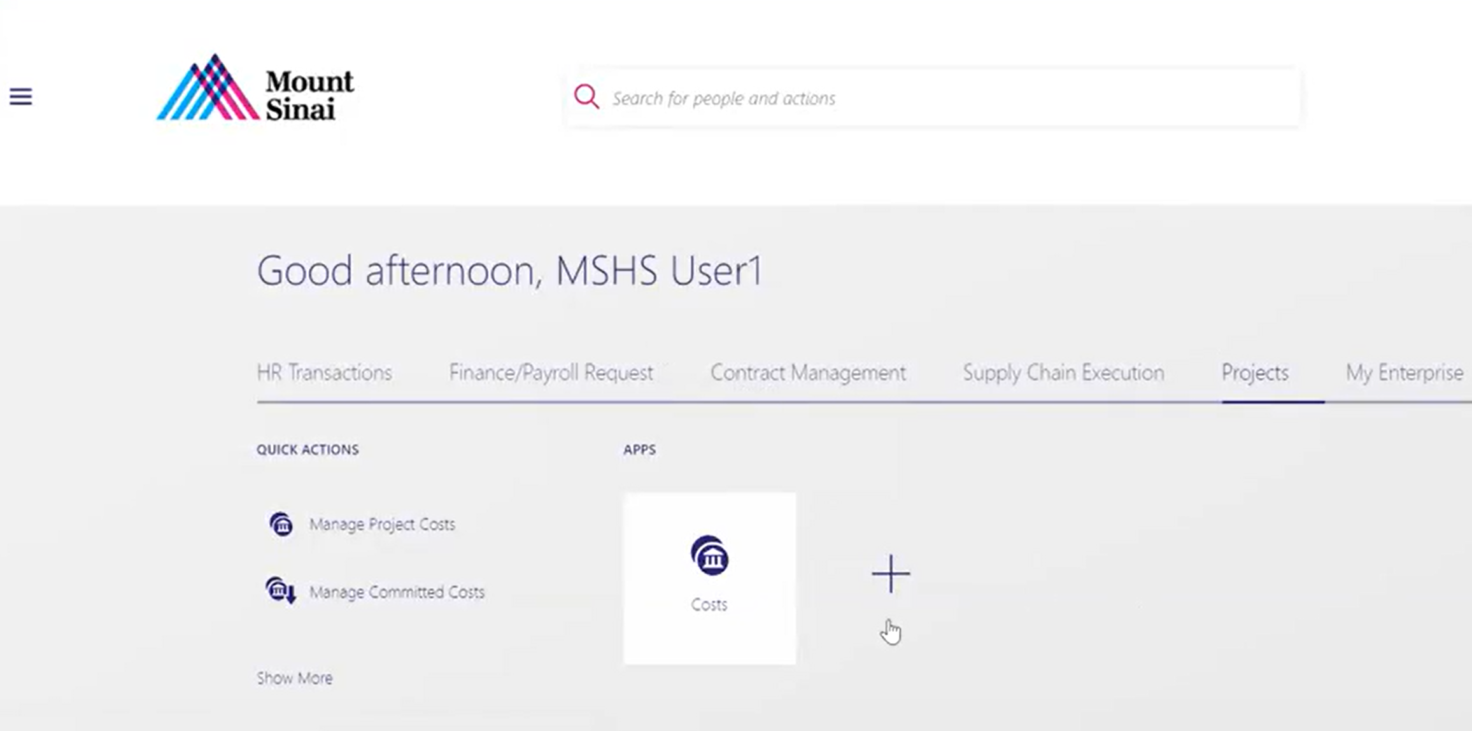
2
1
- On the My Projects screen, select the Task Icon button.
- Select Manage Project Costs to continue.
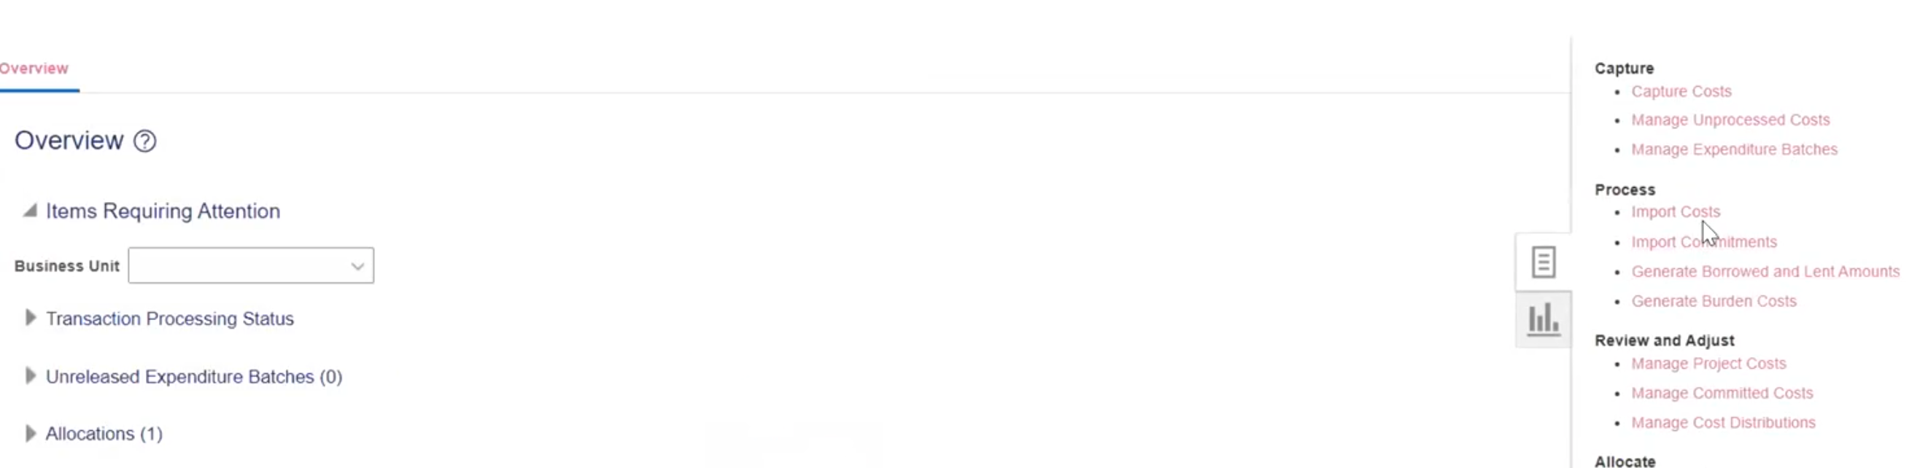
4
3

- Complete at least one of the required fields and click the Search button to search for the first project.

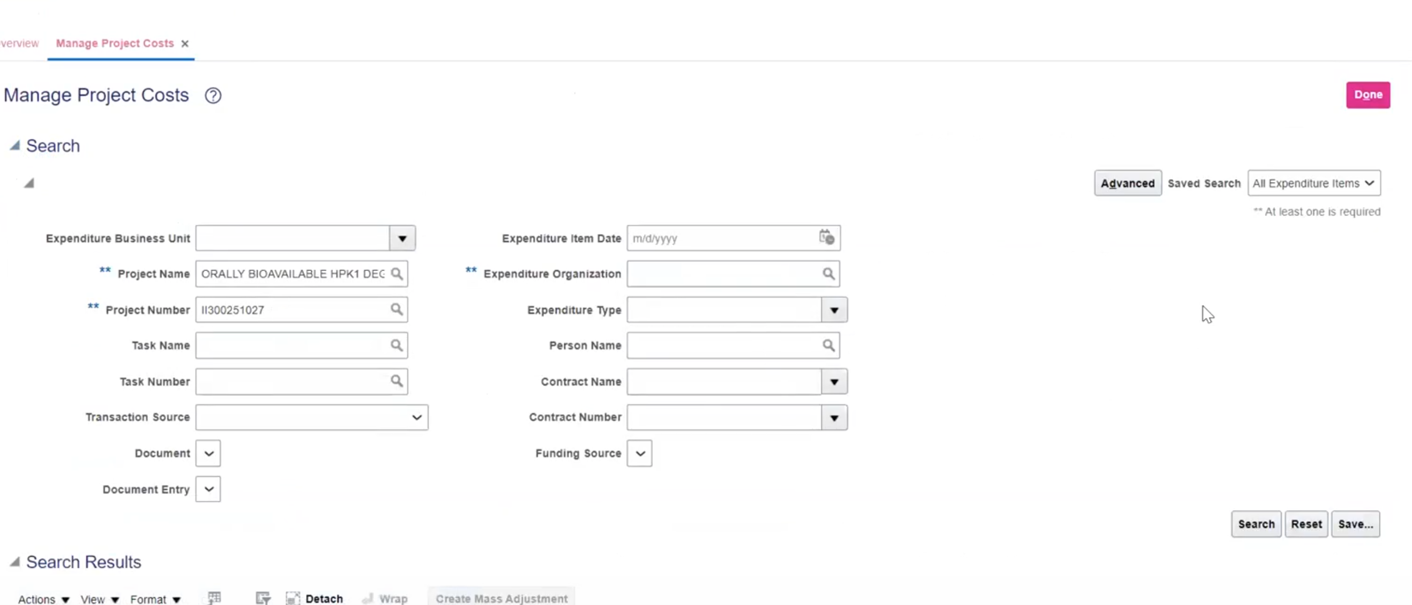
5

- Select the Transaction Number link.

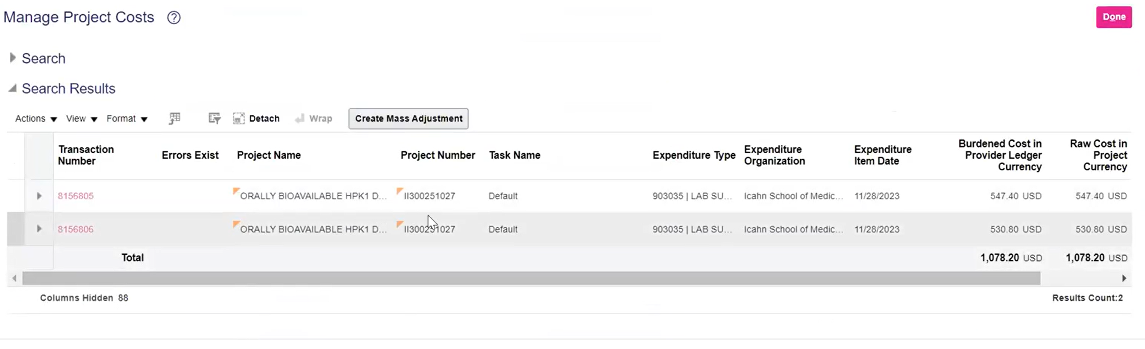
6

- Click the Actions button, then select Costing, then Transfer.

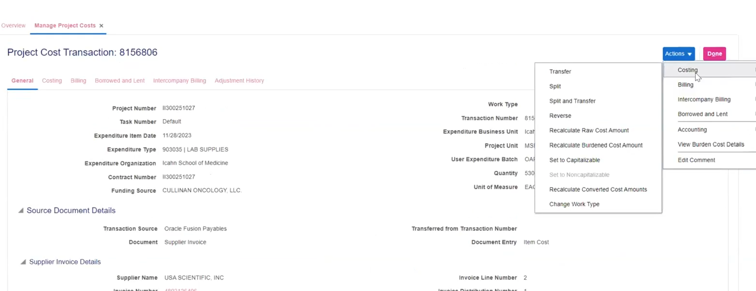
7
 Please note: If a project cost needs to be split, select the Split option. To perform a split and transfer from one project to another, select the Split and Transfer option.

- Complete the following fields with the project the cost should be transferred to:
  - Project Number
  - Task Number
- Select the Submit button.

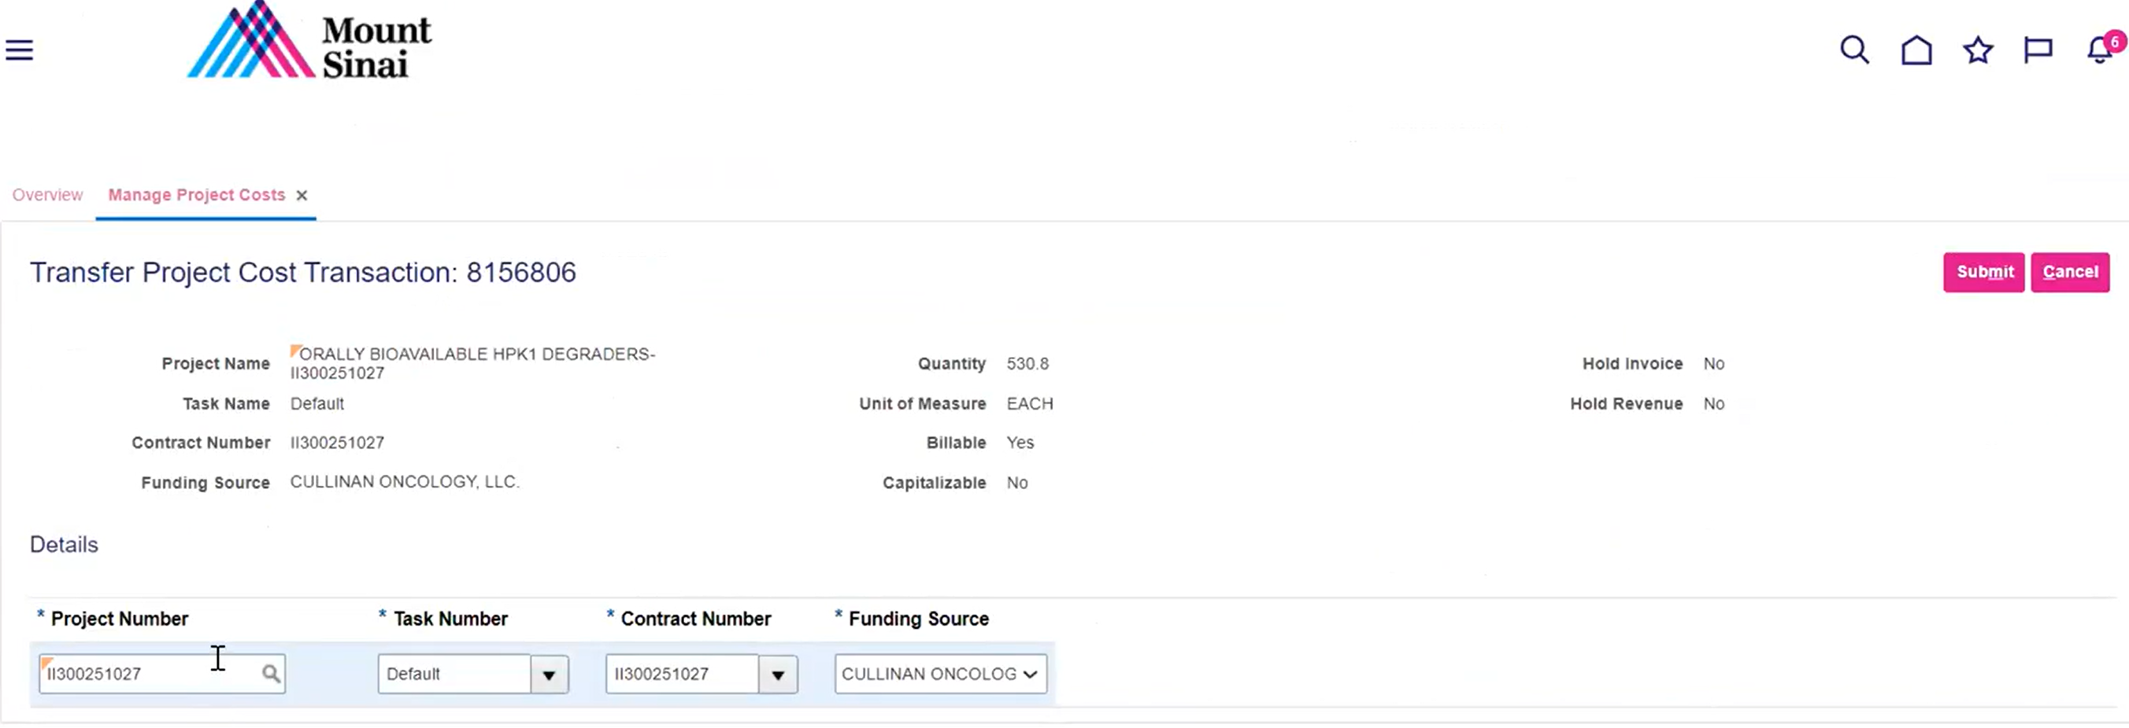
9
8

- Enter the justification reason for the transfer and click the OK button. This process has been completed.

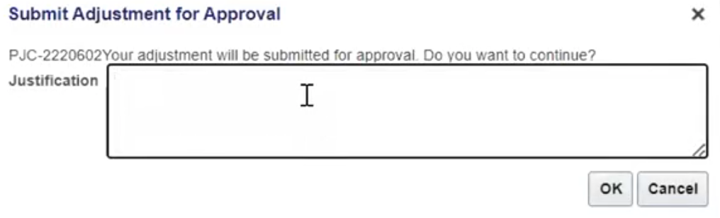
10

Please note: Once submitted, an approval notification is automatically sent to the Project Manager (Principal Investigator) for the project funds being transferred from, and to the Project Manager for the project funds being transferred to. Once the Project Managers have approved the transfers, the transfers will need to be approved by School Finance, which is the final level of approvals.

All necessary documentation should be attached to justify the transfers and to adhere to the MHS compliance policy.

